Simplify your life with the Red Light Therapy . For your convenience, please read the following closely before using the product as it may explain important operating procedures.
The device use combo red 630nm 660nm and Infrared 850nm LEDs which is chosen to give the ideal light intensity for biological effects anywhere on the body .
1 INCLUDE IN THIS PACKAGE
- 1* Light
- 2* Rechargeable Battery 18650
- 1* Battery Charger
- 1* User Manual
2 BENEFITS
Ÿ Temporary relief of minor muscle and joints pain , arthritis and muscle spasm, relieving stiffness , promoting relaxation of muscle tissue .
Ÿ
3 DIRECTIONS FOR USE
Ÿ Hold the unit over the painful area at a distance anywhere from touching the skin to 1 inch away from the skin , depending on the depth of treatment desired . The Red light penetrates up to 1 inch into your tissues or joints .
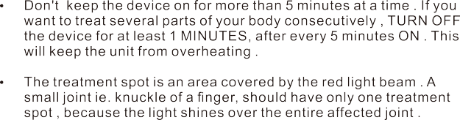
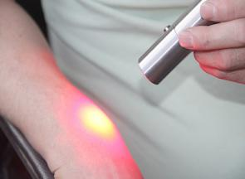
For neck treatment
For knee treatment
For ﬁnger treatment

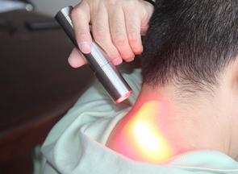

For wrist treatment

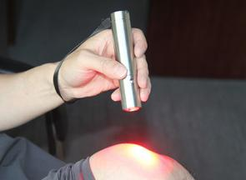
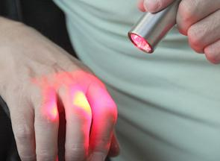
Pain Level | Light Pain | Average Pain | Deep Pain
Dosage | Treatment once a day | Treatment twice or three a day | Treatment three times a day

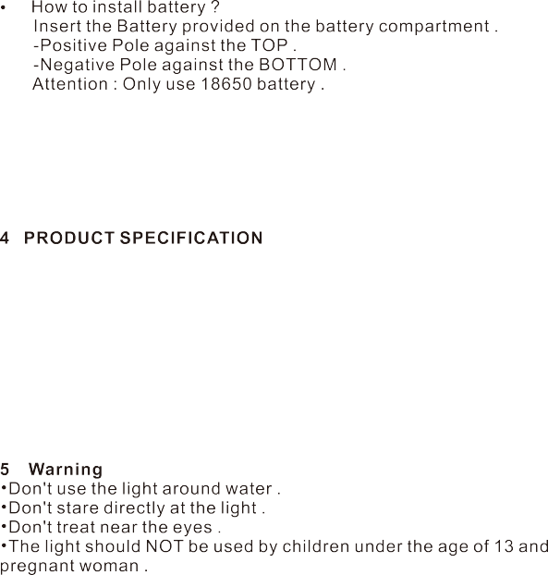
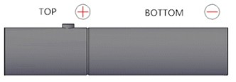
Instruction Manual

TORCH RED LIGHT THERAPY

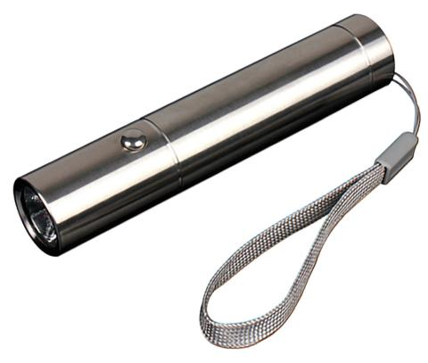

Product Size | D25*125mm | Net Weight | 0.20 KG
Material | Stainless Steel | Wavelength | 630:660:850nm
Irradiance | 1 inch : 133 mW / c ㎡ | Irradiance | 3 inch : 51.0 mW / c ㎡
Illum inance | 180 lux at 15 cm | Battery | 18650
Warranty | 24-Month | Lifespan | 50,000 Hours

